

**Table of Contents**

1. **Introduction**…………………………………………………………………………3
   1. Purpose…………………………………………………………………………...3
   2. Scope……………………………………………………………………………..3
2. **General Description**....……………………………………………………………...4
   1. Product Functions….………………………………………………………….....5
   2. User Characteristics………………………………………………………….......5
3. **Specific Requirements**……………………………………………………………...5
   1. Functional Requirements….……………………………………………………..6
   2. Non-Functional Requirements…………………………………………………...7
4. **Analysis Models**……………………………………………………………………..
   1. Use Case Diagram………………………………………………………………
   2. Class Diagram…………………………………………………………………...
5. **Screens**………………….………………………………………………………….10
6. **Database (ERD)**…………………………………………………………………....
   1. Database Schema….………………………………………………………….....
7. **Web Calls**………....…….…………………………………………………………..
8. **References**…………………………………………………………………………..
9. **Glossary**……………………………………………………………………………28
10. **Introduction**

Room Booking Mobile Application is a modern digital booking system that enables Teachers, Pedagogical Counsellors as well as other Staff members in CEGEP’s Montreal campus to book a room either for an exam or a meeting. Room Booking Application is essential in an office environment because scheduling the shared spaces in a busy office can be a challenge. So this application is specially designed for the purpose of self-service booking. This application is an easy-to-use room booking tool with a simple and organized overview of the availability of the rooms to prevent miscommunication and scheduling conflicts.

1. **Analysis Models**

We are using three analysis and design models to develop our requirements into a mobile application.

**Use case Diagram**

***To be Done***

**Class Diagram**

***To be Done***

* 1. **Use case Diagram**

***To be Done***

* 1. **Class Diagram**

***To be Done***

1. **Screens**

**Screen flow diagram**



**Screen Design**

We can simulate the screens of the app in this tool and verify how it looks when the App is designed. We use drag and drop widgets, screens to design the screens. We used Justinmind Prototyper 8.7.0 to design the Screens. We can simulate these screens with this tool or we can view on our mobile device by connecting it.

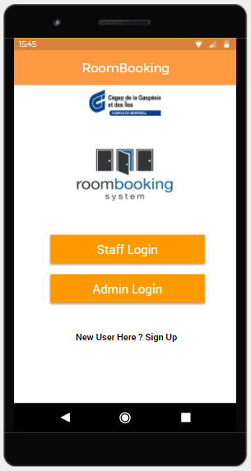

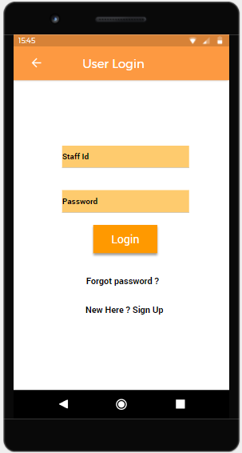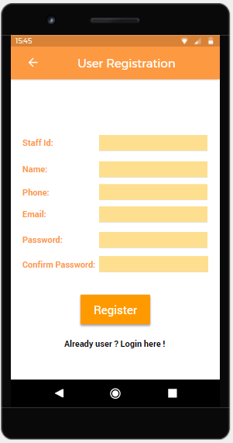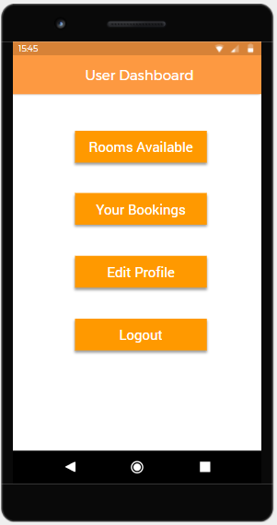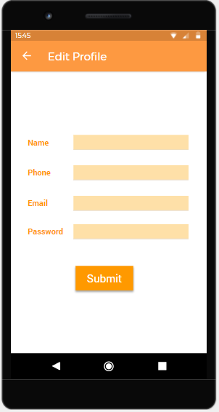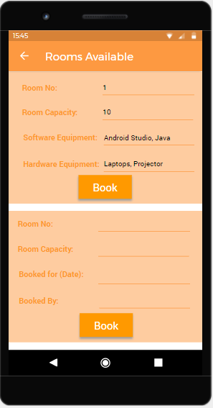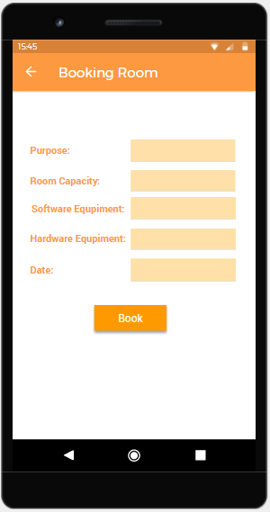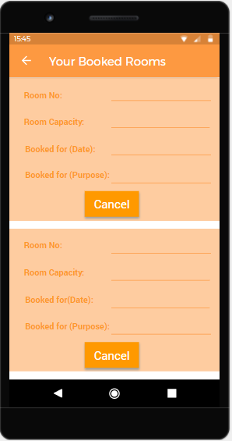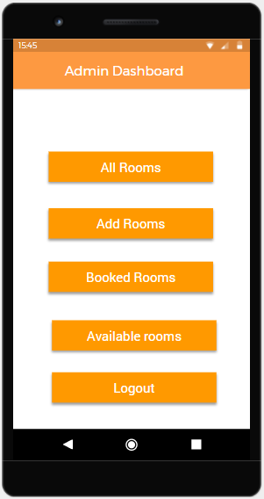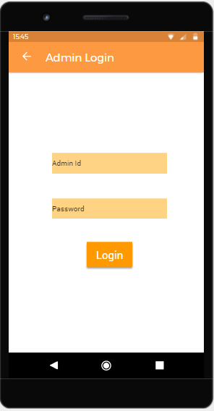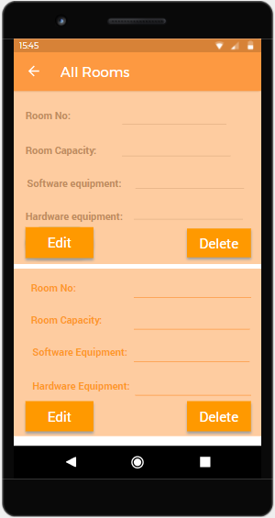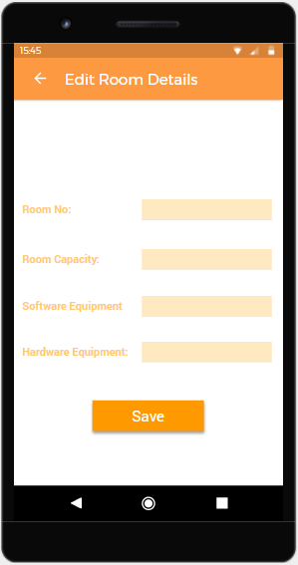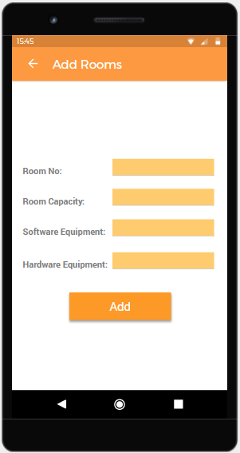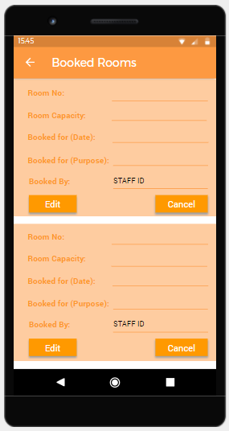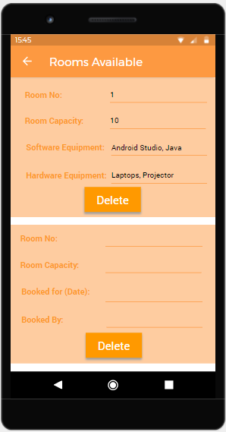

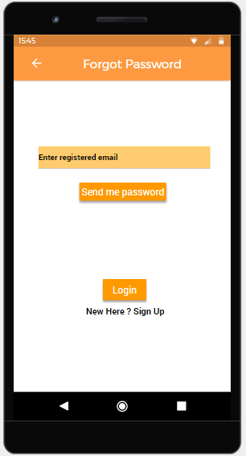

1. **Database (ERD)**

Database is absolutely an integral part of software systems. To fully utilize ER Diagram in database engineering guarantees you to produce high-quality database design to use in database creation, management, and maintenance. An ER model also provides a means for communication.

**ERD Diagram**

***To be Done***

* 1. **Database Schema**

|  |
| --- |
| ***To be Done*** |

1. **Web Calls**

***To be Done***

**Login**

|  |  |  |  |
| --- | --- | --- | --- |
|  | ***To be Done*** | | |
|  |  | | |
|  |  | | |
|  |  | | |
|  |  |  |  |
|  |  |  |
|  |  |  |
|  |  |  |
|  |  |  |

1. **References**

***To be Done***

1. **Glossary**

|  |  |
| --- | --- |
| **24/7** | 24 hours a day, 7 days a week |
| **App** | Application |
| **System** | Mobile Application |
| **User/Staff** | Teachers/ Pedagogical Counsellors/ Other Staff members |

***To be Done***